SOUTH CHINA MORNING POST

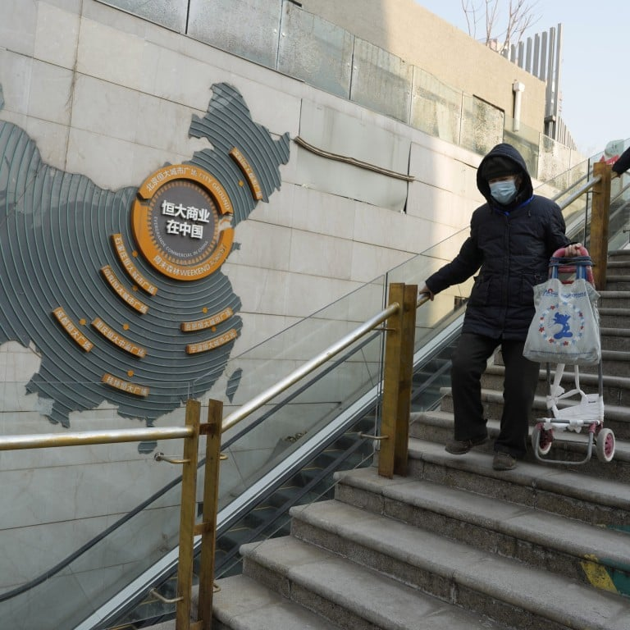
Residents walk through a partially shuttered Evergrande commercial complex in Beijing, on January 29. Photo: AP
Opinion
William R. Rhodes and Stuart P.M. Mackintosh

China must shield the rest of its economy from the property contagion
- Beijing needs to let unsalvageable developers fail and, crucially, avoid saddling banks with bad loans
- Short-term pain is preferable to infecting finance and creating a deeper, longer economic downturn

William R. RhodesandStuart P.M. Mackintosh
Published: 7:30pm, 6 Feb, 2024

As pessimists often note, it will get worse before it gets worse. It looks as if this may be the economic, real estate and banking story that is unfolding in China’s economy.

China Evergrande Group, a massive real estate developer, has been ordered to liquidate by a court in Hong Kong after international creditors pushed to seize its assets. This surely marks the end for the real estate giant, the most highly indebted in the world, saddled with about US$300 billion of liabilities set against assets valued at US$242 billion.

The company reported 1,300 projects across 280 cities. The collapse leaves at least tens of thousands of unbuilt properties, on which many unlucky homeowners have mortgages. Liquidation will be a very painful pill for markets and investors to swallow. But it was not unexpected.

What is more alarming is the extent of the crisis across real estate and other sectors of the world’s second-largest economy, and the real dangers if policymakers opt for pathways that could extend the recession and depth of the downturn.

Evergrande is only part of an even larger real estate collapse, which is affecting China’s economic growth, consumer confidence and prospects. Country Garden, once China’s largest real estate developer by sales, is also in default. JP Morgan estimates that developers responsible for 40 per cent of China’s home sales have defaulted since 2021.

Given the direct link between housing asset values and consumer confidence, and real estate making up 25 per cent of the economy, the impact of the unfolding housing bust is shocking to investors and China’s policymakers.

Professors Atif Mian and Amir Sufi in House of Debt showed us (using the US housing bust of 2007-2008) that deep recessions are always linked to housing price declines. As prices fall, consumers (even those with large down payments) feel poorer and pull back on spending.
This is what hits an economy and its banks especially hard; all economies rely considerably on consumer spending and confidence. When spending slips, confidence drops, the economy slows or contracts. We can see this in the low levels of consumer spending post-Covid in China; a hoped-for rebound did not occur.
China’s policymakers need to avoid creating zombie real estate firms, which stagger on, paying some bills and not others, completing some flats but not all. Restructure if possible, but liquidate as required. Selling to buyers able to build on firmer economic footings will be painful, but it is part of the solution.

Yes, in the short term, the pain is great (as it was in Ireland’s housing bust in 2000). But keeping these companies on expensive financial life support, in the hope they can stagger on to eventual health, could drain resources from the rest of the economy.

This is a key lesson from Japan’s real estate bust. Above all, avoid saddling banks with a growing portfolio of non-performing loans. Doing so constricts lending and the banks react by pulling back other lending and financing to productive parts of the economy. Leaving too much of the burden on banks could extend the drag on the economy. Unfortunately, this may be happening in China.

Xiao Yuanqi, deputy head of China’s National Financial Regulatory Administration, has stressed banks have an “unshirkable responsibility” and urged them to provide “strong support” to real estate firms. This means the extension of new loans to pay off other loans on the books of ailing real estate firms. The People’s Bank of China has also cut bank reserve requirements and urged banks to exercise forbearance on real estate loans. Although understandable, this may risk throwing good money after bad.
China should not risk a “Japanification” of its economy and a long period of slow growth and deflation. With Chinese house prices much higher – at 29 times income in 2020 – than pre-bust Japan, and vacancy rates that are also higher than pre-bust Japan, the dangers of a prolonged downturn are real.
China’s banks should lend only to companies that can recover and restructure their businesses. Risk must be carefully managed. Banks should assume the economic downturn could be prolonged, not that there will be a sudden economic rebound, which is unlikely. Real estate firms that cannot be rescued need to go bust and have their assets sold. Creative destruction must be allowed to take place.
There is one overriding lesson from past housing busts, banking crises and recessions, whether in Ireland, Japan, the United States or China: strict consistent regulation and supervision is needed when a boom is under way, and profits are outsize. During a boom, risk takers always assure officials that their practices and business models are sound. Yet when the boom turns to bust, we often find that many companies were promising unrealistic returns, built on faulty practices.

Avoiding overburdening banks is not the only issue, but banks are the transmission mechanism, the engine of the economy. China’s leaders need to be careful not to infect finance with the real estate sector’s malaise, or the length and depth of the downturn could be far longer than many expect, and the economic pain more widespread and damaging.

William R. Rhodes
William R. Rhodes is president and CEO of William R. Rhodes Global Advisors LLC, and a former CEO of Citibank
William R. Rhodes, a former chairman, CEO and president of Citibank, is president and CEO of William R. Rhodes Global Advisors, LLC, and author of Banker to the World: Leadership Lessons from the Front Lines of Global Finance.

Stuart P.M. Mackintosh
Stuart P.M. Mackintosh is executive director of the Group of Thirty.

